Holy Week with
Lutheran Campus Ministry

-

MAUNDY THURSDAY, April 2 7:00 PM
This night we retell the ancient Passover story. We respectfully share in a traditional Seder Meal that honors our Judeo-Christian roots and also incorporates our understanding of the Last Supper.
GOOD FRIDAY, April 3 7:00 PM
We RETELL the final hours of Jesus’ journey to the cross. A simple, contemplative service of readings, song, and diminishing light.
EASTER VIGIL, April 4 8:12 PM
We RECREATE God’s incredible story of salvation through fire, water, story, and music. It ends with a champagne reception!

Easter Worship
Sunday, April 5
Bethel Lutheran Church
7001 Forsyth Blvd
7:30 AM & 11 AM
A festive service complete with pipe organ & brass! There’s NO Evening Candlelight on Easter.
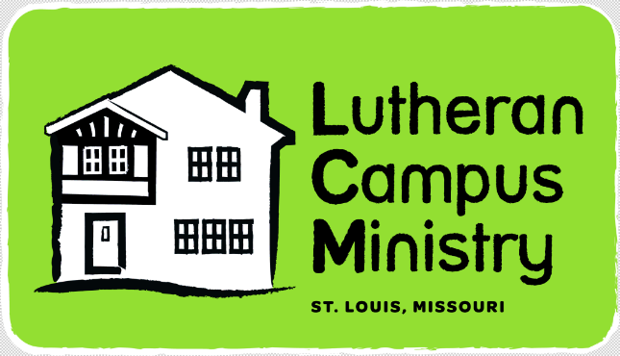

EASTER
BRUNCH
12:15-2ish PM
Delicious food and friendly people ALL ARE WELCOME but please RSVP your # to PR or the Facebook event!

